Home Power Monitor 2

Develop an electric power consumption device for a US home that can be installed in the electric panel to measure voltage/current and computer the complex power. Also analyze the signature of the currents when various appliances in the home turn on and off and detect what they are. Develop a phone App that integrates with the measurements and displays the consumption and other data that can be used to save energy by the user. The developed system will exceed the capabilities of a commercially available device: http://www.sense.com

Find other similar products:
https://shop.emporiaenergy.com/products/vue-3-with-flexible-sensors?variant=46101868675327
https://shop.se.com/us/en/product/wiseremz.html

Find specs for each and find out our own specs
Basic is to just report energy consumption/usage
Focus on one channel first

Use machine learning/AI to learn power consumption

Increase Technical Merit:
Integrate app with smart appliances
Recommendations on what to turn on/off or when

https://console.firebase.google.com/u/0/project/home-power-monitor-752b7/database/home-power-monitor-752b7-default-rtdb/data/~2F?fb_gclid=CjwKCAiA2svIBhB-EiwARWDPjizv888GAEhM022KH9UZbKnHk9gySPG3Y0GHT2k1da_QfivEXf-hbRoCDPAQAvD_BwE

EMBEDDED SYSTEMS PARTS:

MCU Dev Kit Link for Caiden (Just for 403 demo, need another for 404) - https://www.digikey.com/en/products/detail/espressif-systems/ESP32-DEVKITC-32E/12091810?utm_source=chatgpt.com

MCU for PCB Design -
https://www.digikey.com/en/products/detail/espressif-systems/ESP32-WROOM-32E-N4/11613148?

External ADC -
https://www.digikey.com/en/products/detail/texas-instruments/ADS131M04IPWT/10435299?utm_source=chatgpt.com

USB C ports we’ll need in PCB design -
https://www.digikey.com/en/products/detail/molex/2216080001/19092737?utm_source=chatgpt.com

1. Sensor Front End (Kim)
Purpose of AFE-Sense
AFE-Sense takes the dangerous, high-current mains signals (L1, L2) and safely converts them into low-voltage AC signals that the rest of the system can handle. This stage is the front line of protection: it uses current transformers (CTs) and burden resistors to step down large currents into millivolt/volt-level signals. Without this stage, the rest of the board would be exposed to unsafe voltages.
Core Responsibilities
- Sensor Interface
  - Select CTs for measuring L1/L2 currents (and possibly neutral).
  - Size CTs correctly for expected residential loads (0–40 A typical, higher for surges).
  - Choose connectors to safely bring CT leads into the PCB.
- Scaling (Step-Down)
  - Design the burden resistor stage to convert secondary current → safe voltage.
  - Ensure expected loads produce signals in the ~0.5–1.5 V RMS range.
- Filtering & Protection
  - Add a first RC low-pass filter to suppress high-frequency noise.
  - Add protection (TVS diodes, zeners, or clamps) so CTs and downstream circuitry are safe.
  - Guarantee that this subsystem alone never outputs anything above ~2 Vpk.
- Collaboration
  - Deliver safe, low-voltage AC signals to the AFE-Interface teammate.
  - Provide scaling factors (e.g., “1 V RMS at burden = 40 A RMS on mains”).
End-of-Semester Demo
Clamp CT on a load, vary current, and show burden resistor output waveform on oscilloscope. Demonstrate linear scaling with current.

2. Signal Conditioning (Lawson)
Purpose of AFE-Interface
AFE-Interface takes the “safe AC” signals from AFE-Sense and conditions them into clean, MCU-ready inputs. This stage doesn’t step down current anymore — it biases, filters, and buffers so the ESP32’s ADC sees 0–3.3 V signals centered at mid-rail (≈1.65 V).
Core Responsibilities
- Biasing & Level Shifting
  - Design a 1.65 V mid-supply reference from the 3.3 V rail.
  - Use AC coupling to shift incoming ± signals onto the 1.65 V bias.
- Buffering & Drive
  - Select a rail-to-rail op-amp (3.3 V supply) to buffer the biased signal.
  - Decide on unity gain or small gain (1.5–2×) to maximize ADC resolution.
- Final Filtering & Protection
  - Add anti-alias RC filters at the ADC input (e.g., 1 kHz cutoff).
  - Protect the ADC pins with small resistors, TVS, or clamps.
- Collaboration
  - Deliver calibrated 0–3.3 V centered signals to the DSP teammate.
  - Provide scaling documentation (e.g., “ADC value X corresponds to 10 A RMS”).
End-of-Semester Demo
Take the output from AFE-Sense, pass it through this circuit, and show a 0–3.3 V centered waveform on oscilloscope and MCU ADC plots.

3. Embedded Systems (Caiden)

Purpose of the DSP Role
The DSP engineer ensures the raw analog signals (voltage & current from the AFE) are digitized, processed, and transformed into meaningful electrical measurements. They build the foundation of all the logic above them (ML, App).
Without DSP, the ML guy has no features to classify, and the app guy has no numbers to display.

Core Responsibilities
- Signal Acquisition
  - Configure and control the ESP32 ADCs (sample current & voltage at the right rate).
  - Manage timing (sampling frequency, frame length, buffering).
  - Ensure synchronized voltage/current capture for accurate phase and power factor.
- Signal Processing
  - Compute RMS voltage & current.
  - Detect phase difference between V & I (for real/reactive power).
  - Implement Fourier Transform (FFT/DFT) to extract harmonic content (2nd, 3rd, etc.).
  - Filter signals (low-pass, high-pass) to clean noise before analysis.
- Feature Extraction
  - Calculate key metrics:
    - Real, reactive, and apparent power (P, Q, S).
    - Power factor (true vs. displacement).
    - Harmonic distortion (THD).
  - Format those metrics into feature sets for the ML role.
- Data Streaming
  - Package processed features into a JSON or similar format.
  - Send to the ML teammate for classification and/or to the App teammate for display.
  - Optimize for bandwidth if data is streamed over Wi-Fi.
- Integration & Validation
  - Work closely with AFE to confirm scaling factors (ADC counts → volts/amps).
  - Provide raw + processed data so the ML guy can test detection accuracy.
  - Debug with the App teammate to confirm values display correctly.

4. Machine Learning (Josh)

Purpose of the ML Role
The ML role makes the system smart. While the AFE + PCB + DSP handle capturing and preparing raw signals, the ML guy is the one who turns that data into useful insights: detecting and classifying electrical devices (e.g., “fridge just turned on,” “microwave running,” etc.).
Without him, the system only outputs voltage/current numbers. With him, it becomes a tool that can track energy usage per device and help users save power.

Core Responsibilities
- Data Pipeline
  - Work with the DSP teammate to define what features will be passed along (RMS current, harmonics, power factor, etc.).
  - Ensure data is formatted consistently (JSON or CSV logs).
  - Pre-process signals into usable features for ML (normalization, filtering).
- Feature Engineering
  - Identify what measurements best distinguish one device from another:
    - Step changes in RMS current.
    - Harmonic content (2nd, 3rd, etc.).
    - Phase shifts.
    - Duty cycles and timing patterns.
- Model Development
  - Select and train ML models (start simple: decision trees, k-means clustering, logistic regression; then possibly neural networks).
  - Train models on simulated or collected datasets (household appliances).
  - Evaluate accuracy, false positives, and robustness.
- Device Detection Logic
  - Implement algorithms that detect events (when a device switches on/off).
  - Map those events to specific device signatures.
  - Maintain a device library that expands as the system “learns” new devices.
- Integration
  - Package the detection logic so it can run in real time on the ESP32 or in a connected app/cloud service.
  - Work closely with DSP and App teammates to ensure the results are both technically correct and user-friendly.

5. Mobile / Web App (Vivek)
Role:
Provide a user interface for monitoring, alerts, and control.
Tasks:
- Display real-time voltage, current, power, and energy usage.
- Visualize historical energy consumption trends.
- Show appliance-specific energy usage (from ML subsystem).
- Send notifications for unusual consumption or system faults.
- Allow configuration of user preferences and thresholds.

Integration Rules
- Sampling rate & frame size locked: fs = 4.096 kHz, N = 1024 samples, Hann window.
- JSON schema locked: {t, rms_v, rms_i, p, s, pf, thd, harmonics}.
- AFE isolation rule: no mains-level testing until AFE validated safe.
- Demo path: Capstone I = synthetic → FFT → JSON → app graph.

JSON PACKAGE
{
"t": 1757303797457,
"frame_id": 420,
"fs": 4096, (kHz)
"N": 1024,
"window": "hann",
"freq_hz": 60.00,

"rms_v": 120.0,
"rms_i": 6.043,
"p": 623.538,
"s": 725.165,
"pf_true": 0.860,

"v1_rms": 120.0,
"i1_rms": 6.000,
"phi_deg": 30.0,
"phi_convention": "phi = angle(V1) - angle(I1); positive = current lags",
"p1": 623.538,
"q1": 360.000,
"s1": 720.000,
"pf_disp": 0.866,

"thd_i": 0.120,
"thd_v": 0.010,
"h_i": {"120": 0.12, "180": 0.00, "240": 0.00, "300": 0.00},
"odd_sum_i": 0.000,
"even_sum_i": 0.120,
"crest_i": 1.512,
"form_i": 1.117,

"state": "on",
"d_irms": 3.039,
"d_p": 311.769,
"events": [{"type": "on", "t": 1757303797457}],

"fw": "sandbox-0.2.1",
"cal_id": "sim-default",

"harmonics": {"120": 260.422, "180": 0.003}
}

Who uses what (at a glance)
- App/UI: p, rms_v, rms_i, pf_true, pf_disp, q1, state, events, freq_hz.
- DSP/EE sanity: v1_rms, i1_rms, phi_deg, p1/q1/s1, thd_i/v, fs/N/window.
- ML/device ID: h_i, thd_i, odd_sum_i, even_sum_i, crest_i, form_i, d_irms, d_p, optionally state labels for supervised training.
- QA/ops: fw, cal_id, frame_id.

DEFINITIONS:

Frame & reproducibility
- t: Epoch ms. Use for charts/time axis.
- frame_id: Monotonic counter; handy if timestamps jitter.
- fs, N, window: Sampling rate, frame size, and window name so anyone can replicate FFT math exactly.
- freq_hz: Estimated line frequency (e.g., 59.97–60.03). Good for status/diagnostics.

Core power (what the app shows big)
- rms_v (V), rms_i (A): Per-frame RMS.
- p (W): Real/active power = mean(v*i). Primary number users care about.
- s (VA): Apparent power = Vrms * Irms.
- pf_true: True power factor = P / S. Drops when harmonics rise or φ grows.
App can plot P, show PF badge, and trend RMS values. These alone are enough for a solid demo.

Complex (fundamental-only) power — “electrical correctness”
Extracted from the 60 Hz phasors:
- v1_rms, i1_rms: Fundamental-only RMS for V and I.
- phi_deg: Angle(V1) − Angle(I1). Positive ⇒ current lags (inductive).
- p1 (W), q1 (var), s1 (VA): Fundamental real/reactive/apparent power.
- pf_disp: Displacement PF = cos(phi).
App can show Q/quadrant (lagging vs leading). Great to explain why pf_true < pf_disp when distortion exists.

Distortion features (for device detection / ML)
- thd_i, thd_v: Total harmonic distortion (ratio, not %).
- h_i: Normalized harmonic magnitudes of current (e.g., "120": 0.12 means 12% of fundamental). Stable across scaling/cal changes.
- odd_sum_i, even_sum_i: Aggregate odd vs even harmonic content (often device-specific).
- crest_i: Peak/RMS; spikes for peaky loads (rectifiers, LED drivers).
- form_i: RMS / average-rectified; another waveform-shape cue.
ML teammate uses these features + d_irms/d_p deltas to classify on/off and identify device signatures.

Event helpers (for step detection & UX)
- state: "on" / "off" (from our simple simulator now; later from edge logic).
- d_irms, d_p: First differences vs previous frame — quick way to detect steps.
- events: Debounced markers (e.g., on/off). App can render vertical event lines on charts.

Metadata / calibration
- fw: Firmware/sandbox version string—useful when logs come from different builds.
- cal_id: Which calibration constants were used (ADC→V/A). Prevents mixing apples and oranges.

Back-compat / display-only
- harmonics: Raw FFT magnitudes at 120/180 Hz (not normalized). Quick for plots/debug; ML should prefer h_i.

PCB GUIDE

Must-have blocks (to make the PCB actually run)
- Compute module
  - ESP32-WROOM-32 (classic) or ESP32-S3-WROOM-1 (newer).
  - Antenna keep-out on the PCB (no copper under/around the antenna).
- Power
  - 3.3 V regulator (500–800 mA headroom). Examples: AP2112K-3.3, RT9080-3.3.
  - Input: choose USB-C 5 V or a screw-terminal (5–12 V) → buck → 3.3 V.
  - Decoupling: 0.1 µF near every VDD pin + bulk (10–47 µF) per rail.
- Programming & debug
  - EITHER a USB-UART bridge (CP2102N / CH340K) + USB-C receptacle, ESD diode, and the auto-boot wiring (EN/IO0).
  - OR a 6-pin UART header (3V3, GND, TX, RX, EN, IO0) for an external USB-UART dongle.
  - Buttons: EN (reset) + BOOT (IO0).
  - Status LEDs: Power + a user LED on a GPIO (via 1 k).
- Connectors & testability
  - Test pads for 3V3, GND, TX, RX, SCLK/MISO/MOSI/CS (if you add an external ADC).
  - Mounting holes, fiducials, and silkscreen labels on all connectors.

AFE / sensing chain (for real signals later)
(You can skip this this semester if you’re simulating in firmware—just design footprints now so you can drop parts in next term.)
- Current inputs (CTs)
  - Burden resistors sized for your CTs to land ~±0.5…1.0 V full-scale.
  - RC anti-alias (e.g., 100 Ω + 1–2.2 nF) to your ADC’s bandwidth.
  - Input protection (TVS or clamp, e.g., SMAJ5.0 + series R).
  - 3.5 mm pluggable terminals for CTs; label polarity.
- Voltage input (line) – SAFETY FIRST
  - Easiest/safest: a small AC potential transformer to isolate line → low AC; then scale/filter.
  - If using a resistor divider directly: use mains-rated resistors, fusing, MOV, spacing/creepage, and preferably an isolated amplifier (e.g., AMC1311) before the ADC domain.
  - Creepage slots, clearances ≥ the code you’re targeting (be conservative).
- ADC stage (recommended for accuracy)
  - External metering ADC (SPI):
    - Beginner-friendly 16-bit: ADS1115 (single-ended; simple but limited).
    - Purpose-built metering: ADS131M04 (TI, 24-bit, 4-ch sigma-delta), or ATM90E32 (Microchip energy-meter SoC).
  - Precision reference (if ADC needs it): 2.5 V/4.096 V ref (e.g., REF5025/ADR4525).
  - Clock as required by the ADC (often internal).
  - Digital interface: SPI lines to ESP32 with series resistors; if you keep high-voltage domain isolated, use a digital isolator (ISO7741/ADuM series) and isolated DC-DC (e.g., Murata/RECOM 5V→5V iso + LDO to 3.3 V).

Protection, safety, and EMC
- Front-end protection
  - Input fuse(s), MOV at the mains tap, NTC inrush (optional).
  - TVS diodes on external connectors, especially USB-C and long sensor leads.
  - Common-mode chokes on USB and long cables if noise becomes an issue.
- Layout & mechanical
  - Separate HV (mains) zone and LV (logic) zone with a physical isolation moat (milled slots) and clear silkscreen boundaries.
  - Star ground for analog front-end; solid ground under digital.
  - Keep the ESP32 antenna at a PCB edge, away from ground pour and tall metal parts, and avoid enclosures/heat-sinks nearby.

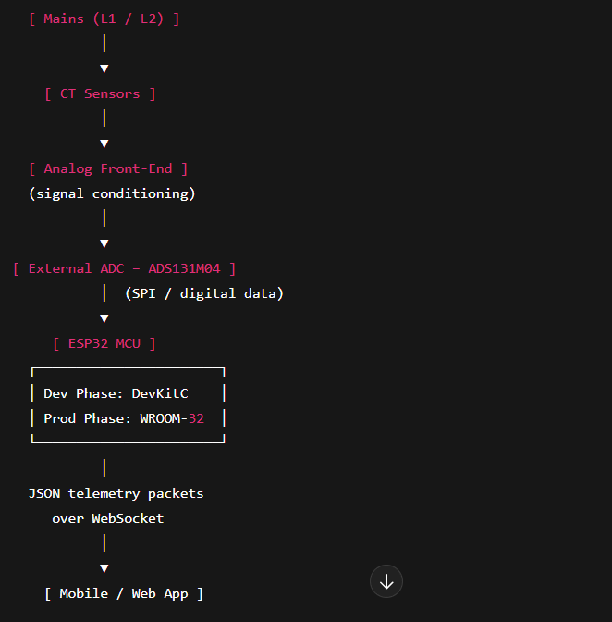

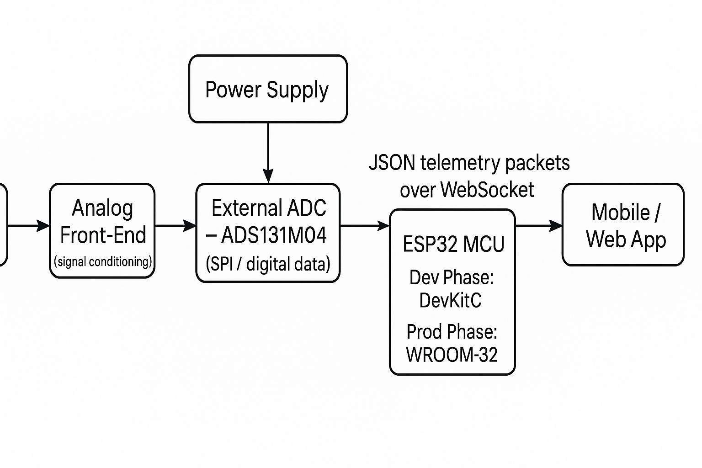

Presentation:

OPENING STATEMENT:
My name is Kim Peteros, and I’m the team lead for OhmSweetHome.
I’m joined by my amazing teammates: Lawson Parr on Signal Conditioning, Caiden Rueben on Embedded Systems, Joshua Le leading Machine Learning, and Vivek Samuel developing our Mobile Application.
Before we start, I think we can all agree that — electricity prices have been climbing fast, and every month the bill seems to find a new way to surprise us. Whether it’s running the AC through the Texas heat or leaving too many things plugged in, those costs keep adding up — and the frustrating part is, most of us don’t really know where that energy is going.
That’s the problem our team set out to solve.
Together, we're building a system designed to shine a light on your home’s energy usage.
Instead of just seeing one big number on your monthly bill, we want homeowners to actually see which appliances are drawing power in real time.
Here’s how our system brings that idea to life:
Everything starts at the home’s main power lines, where we capture the unique electrical “signatures” created by different appliances.
The Sensor Front End measures that current safely and sends it to the Signal Conditioning stage, where the signal is filtered, centered, and scaled for processing.
From there, the Embedded System — powered by an ESP32 — digitizes the data and transmits it wirelessly.
Our Machine Learning model then analyzes those patterns to determine which appliances are running, and finally, the Mobile App displays it all through an intuitive, real-time dashboard.
My subsystem — the Sensor Front End — is where it all begins.
It takes the high mains current and safely converts it into a low-voltage signal that our electronics can understand.
We’re using current transformers rated up to 150 amps, paired with burden resistors to turn that current into voltage.
The signal then passes through an RC filter to smooth out noise and through protection clamps that limit it to about 1.65 volts peak.
What we end up with is a clean, stable signal — the foundation for every accurate reading that follows.
Now that we’ve captured a safe and reliable signal, Lawson will take it from here and explain how the Signal Conditioning subsystem fine-tunes that data for the next stage.

PROJECT EXECUTION AND VALIDATION:
Now moving on to Project Execution and Validation — here’s how our team is organizing the development process. We first started with research and are now starting to move onto initial design and testing.
CLOSING STATEMENT:
To wrap things up, our project — Ohm Sweet Home — started with a simple question:
Why do we pay for energy we don’t fully understand?
Our mission has been to change that. Although we’re still early in development, the vision is clear. Once built, Ohm Sweet Home will take something as complex as household electrical data and turn it into clear, real-time insights that help homeowners make smarter decisions, cut waste, and ultimately save money.
We’re proud of how far we’ve come and even more excited about where we’re heading. Our next step is to move onto design and simulation and finally finish off with testing and integration.

EMBEDDED SYSTEMS:

So I’m on the embedded systems side of the project, it’s the control and processing core that runs all the data handling for our Home Power Monitor.
I’m using an ESP32 microcontroller, which takes in the conditioned voltage and current signals from the analog front end, processes them in real time, and sends that information out over Wi-Fi.
The MCU will calculate all the key electrical metrics, things like RMS voltage and current, real, reactive, and apparent power, and power factor.
All of that data will be packaged into a JSON frame that updates about four times per second, and gets sent to the app so users can see everything happening in real time.
To develop this, I started with a Python sandbox, which uses simulated voltage and current signals to test the math and data structure, then later I will port everything over to C++ on the ESP32 using VS Code and PlatformIO.
Once the MCU is booted up, the code will run in a continuous loop, handling all missing data, and streaming consistent JSON packets so it functions as the link between our sensing hardware and the mobile app.
By the end of the semester, the ESP32 will be fully standalone reading simulated sensor data, calculating power metrics efficiently, and wirelessly pushing that to the app. This subsystem essentially ties everything together through real-time processing, bridging the analog front end with the software side of the project.
With that, I’ll pass it over to Josh.
MACHINE LEARNING:
I’m Josh and I’m responsible for the Machine Learning subsystem of our project
So — what does this subsystem actually do?
It serves as the intelligence layer of the system. Once our sensors and DSP extract electrical data, I use the ML model to interpret it and answer the core question:
“What appliance just turned on or off?”
By translating raw numerical signals into human-understandable insights, my subsystem makes the entire system smart — connecting the low-level electrical data to the meaningful information the user sees in the app.
Now, how did I design it?
I started with a public dataset called PLAID, which contains labeled electrical signatures from common household appliances.
From that data, I generated electrical ‘fingerprints’ — patterns that uniquely identify each device.
I then trained a Random Forest Classifier to recognize those fingerprints.
A Random Forest combines multiple decision trees, and through majority voting, it produces a more reliable and accurate prediction.
Once trained, I deployed the model to the cloud behind a REST API, which basically acts as a bridge between systems.
This allows the embedded system and mobile app to send real-time data to my model and receive instant predictions back — like “washer detected” or “microwave turned on.”
That way, instead of running everything locally, the ML model can handle live classification requests from anywhere.
In short, my subsystem transforms raw electrical data into meaningful insights, powering the intelligence behind our entire project.
Now that I can identify which appliances are running, I’ll pass it to Vivek, who’ll explain how the mobile app delivers those insights directly to the user through an interactive dashboard.
Signal Conditioning:
My subsystem is the Signal Conditioning stage, which takes the raw current transformer output and prepares it for the ESP32’s ADC.
In simple terms, it shifts and shapes the waveform so the microcontroller can digitize it accurately without distortion or clipping.
The main goals here are to keep the signal within the 0 to 3.3-volt range that the ESP32 expects, to center it at mid-rail around 1.65 V, and to filter out high-frequency noise while preserving the 60 Hz waveform and its harmonics — since those harmonics are what the DSP subsystem uses for power analysis.
The circuit itself has three stages:
- A biasing network made of a dual 100-kΩ voltage divider and AC-coupling capacitor to set that 1.65 V mid-rail.
- A buffering stage using a rail-to-rail op-amp configured as a unity-gain follower, which keeps the signal stable and low-impedance for the ADC.
- And a low-pass RC filter tuned around 1.6 kHz that removes high-frequency noise and EMI before sampling.
All of this ensures that the ESP32 receives a clean, centered, and properly scaled waveform to calculate accurate RMS and power readings later on.
So far, I’ve simulated the full bias-buffer-filter chain in Multisim to confirm it produces a clean 0–3.3 V output, and I’m now moving toward breadboard testing to verify stability with real CT signals.
Once validated, this design will be turned into a PCB that connects directly to the ESP32 input pins, providing the reliable, noise-free analog interface the entire system depends on

App Dev:
My role is Application Development, which will serve as the main interface between our system and the user. The app takes data from the embedded system and machine learning model and turns it into something clear and useful for homeowners.
The goal is to make energy data easy to understand. The app won’t just show total usage — it will break down how much each appliance is consuming and how that changes over time. It will display both real-time and historical data, and will eventually include cost tracking and simple graphs to help users spot where they can save energy.
To do this, I’ll be building the app with Flutter, which lets us develop for both Android and iOS from a single codebase.
My plan starts with building the core navigation structure, with pages for Real-Time Data, Historical Trends, and Appliance Detection. Next, I’ll set up the system to handle JSON data from Caiden’s ESP32 to ensure the data flow is working correctly. After that, I’ll integrate charting features so users can see their energy usage visually, and I’ll add local storage so the app can keep a history even when it’s offline.
By the end of the semester, the app will be able to receive live JSON frames from the ESP32, display that data in real time, and show which appliance is active based on predictions from Josh’s machine learning subsystem.
Overall, my focus is on making sure all the technical data our system collects is displayed in a way that’s simple, intuitive, and actually helps people save money and reduce waste.
With that foundation in place, we can now take a quick look at Project Execution and Validation.

Perfect, with those files I can be super concrete.
You really only need to touch main.cpp.
Below are copy-paste patches for:
- Defining the appliance profiles
- Using them in loop() when TEST_MODE is enabled
- Injecting labels into the JSON you push to Firebase

1. Add profiles + struct near the top of main.cpp
In main.cpp, right after:
static constexpr float THDV_PLACEHOLDER = CFG_THDV_PLACEHOLDER; // mirrors your sim

add this:
// ─────────────────────────────────────────────────────────────────────────────
// Synthetic appliance profiles for TEST_MODE (used to simulate breaker data)
// ─────────────────────────────────────────────────────────────────────────────

struct ApplianceProfile {
const char* name;
float I_RMS_ON; // amps (approx)
float H2_ON; // ratio wrt fundamental
float PHASE_DEG; // degrees
};

static const ApplianceProfile PROFILES[] = {
// Big motor/compressor, high-ish current, moderate distortion
{"Air Conditioner", 10.0f, 0.635f, 50.6f},

// Small lighting loads
{"Compact Fluorescent Lamp", 0.30f, 0.082f, 26.4f},
{"Incandescent Light Bulb", 0.60f, 0.096f, 22.3f},

// Small–medium motor loads
{"Fan", 1.00f, 0.121f, 20.0f},
{"Fridge", 3.00f, 0.800f, 44.7f},

// High-power resistive / mixed
{"Hairdryer", 12.00f, 0.119f, 16.7f}, // ~1400 W
{"Heater", 12.00f, 0.130f, 15.4f}, // ~1400 W

// Electronics / SMPS
{"Laptop", 0.50f, 0.033f, 25.8f},

// High-power mixed (magnetron etc.)
{"Microwave", 9.00f, 0.324f, 37.1f}, // ~1000 W

// Other large motor-ish loads
{"Vacuum", 10.00f, 0.143f, 35.6f}, // ~1200 W
{"Washing Machine", 8.00f, 0.800f, 87.3f}, // peaks + motor
};

static constexpr int NUM_PROFILES = sizeof(PROFILES) / sizeof(PROFILES[0]);

// Index of current simulated appliance when TEST_MODE is enabled
static int profile_idx = 0;

Note: we leave I_RMS_ON, H2_ON, PHASE_DEG from config.h alone for the real ADC path (non-TEST_MODE). We only override them in TEST_MODE.

2. Use the current profile in loop() (TEST_MODE path)
In loop(), find this block:
// ── 1) Update ON/OFF state machine
update_on_off_state();
const float irms_target = state_on ? I_RMS_ON : I_RMS_OFF;
const float h2_amp = state_on ? H2_ON : H2_OFF;
const char* state_str = state_on ? "on" : "off";

// ── 2) Acquire / Synthesize signals
#if TEST_MODE
// Synthetic V/I like your sandbox (includes harmonic 2 content on current)
signals::vi_test_signals(FS, N, V_RMS_TARGET, irms_target, F0, PHASE_DEG, h2_amp, v, i);
#else
// TODO: Replace with dual-channel ADC fill (remove bias, scale to volts/amps)
// adc::fill_dual(v.data(), i.data(), N); // example API
// dsp::remove_dc(v.data(), N);
// dsp::remove_dc(i.data(), N);
#endif

Replace that entire block with:
// ── 1) Update ON/OFF state machine
update_on_off_state();
const char* state_str = state_on ? "on" : "off";

// In TEST_MODE, drive the synthetic signals from a specific appliance profile.
// In real mode (ADC), these constants from config.h still matter.
float irms_target = state_on ? I_RMS_ON : I_RMS_OFF;
float h2_amp = state_on ? H2_ON : H2_OFF;
float phase_deg = PHASE_DEG;

#if TEST_MODE
// Override with current simulated appliance profile
const ApplianceProfile& prof = PROFILES[profile_idx];
irms_target = state_on ? prof.I_RMS_ON : I_RMS_OFF;
h2_amp = state_on ? prof.H2_ON : H2_OFF;
phase_deg = prof.PHASE_DEG;
#endif

// ── 2) Acquire / Synthesize signals
#if TEST_MODE
// Synthetic V/I for breaker simulation (includes harmonic 2 content on current)
signals::vi_test_signals(FS, N, V_RMS_TARGET, irms_target, F0, phase_deg, h2_amp, v, i);
#else
// TODO: Replace with dual-channel ADC fill (remove bias, scale to volts/amps)
// adc::fill_dual(v.data(), i.data(), N); // example API
// dsp::remove_dc(v.data(), N);
// dsp::remove_dc(i.data(), N);
#endif

(Optional) auto-rotate appliances
Right after the existing event detection block (still in loop()):
// ── 8) Event detection (simple step on Irms)
latest_event.clear();
if (fabsf(d_irms) > 1.0f) {
latest_event["type"] = (d_irms > 0) ? "on" : "off";
latest_event["t_ms"] = static_cast<uint64_t>(now_ms());
}

you can add this to cycle through different appliances every few OFF events:
#if TEST_MODE
// After a few ON→OFF cycles, advance to the next appliance profile
static int off_cycles = 0;
if (!latest_event.isNull() && latest_event.containsKey("type")) {
const char* t = latest_event["type"];
if (t && strcmp(t, "off") == 0) {
if (++off_cycles >= 4) { // every 4 OFF events, move to next appliance
off_cycles = 0;
profile_idx = (profile_idx + 1) % NUM_PROFILES;
}
}
}
#endif

This is optional; if you want to keep one appliance forever for now, skip it.

3. Add labels into the JSON before sending to Firebase
Near the bottom of loop(), find this part:
const uint64_t t_ms = utils::now_ms(); // keep your existing util (e.g., epoch-based)
String json = pack_frame_json(
t_ms, frame_id, FS, N, WINDOW_NAME, F0, core, h_i, state_str,
zf(d_irms), zf(d_p),
/* include_core = */ true,
/* include_harm = */ true,
/* include_event= */ true,
CFG_FW_TAG,
CFG_CAL_ID
);

// ── 10) Output logs
Serial.println(json);

Change it to:
const uint64_t t_ms = utils::now_ms(); // keep your existing util (e.g., epoch-based)
String json = pack_frame_json(
t_ms, frame_id, FS, N, WINDOW_NAME, F0, core, h_i, state_str,
zf(d_irms), zf(d_p),
/* include_core = */ true,
/* include_harm = */ true,
/* include_event= */ true,
CFG_FW_TAG,
CFG_CAL_ID
);

#if TEST_MODE
// Inject ground-truth labels for training when we are simulating
StaticJsonDocument<256> doc;
auto err = deserializeJson(doc, json);
if (!err) {
JsonArray labels = doc.createNestedArray("labels");
if (state_on) {
labels.add(PROFILES[profile_idx].name);
}
json = "";
serializeJson(doc, json);
}
#endif

// ── 10) Output logs
Serial.println(json);

Everything else in loop() (the Serial.printf, fb_push_frame, frame pacing) can stay as-is.

4. Files you don’t need to change
- signals.cpp – already provides vi_test_signals, which we’re using.
- telemetry.cpp – pack_frame_json stays unchanged.
- firebase.cpp, dsp.cpp, utils.cpp – no changes needed.

If you paste these changes into main.cpp, recompile, and run with TEST_MODE enabled, you’ll get:
- ESP simulating realistic appliance waveforms for each profile
- Each JSON frame tagged with "labels": ["Microwave"] / "Hairdryer" / etc.
- Frames pushed to Firebase exactly like before, but now ready for ML training.
If you want, next step I can show you a tiny Python script to pull those frames from Firebase, turn them into a features JSON, and retrain your model on the new simulated data.

